BİLGİ FÖYÜ

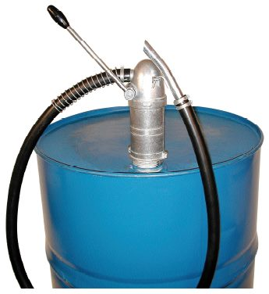
JESSBERGER HAND PUMP JP-16
ATEX compliant fire hand pump JP-16
Single-acting reciprocating pump, for the following
Media derGefahrenklassen AI is used-III:
Diesel, fuel oil EL / L, fuels, petroleum, cooler Frost
medium (undiluted), low viscosity mineral oils and RME
Fire design with flexible hose
Suction hose DN 19 x 4, 1.5 m
Discharge hose, DN 19 x 4, 1.5 m
The built-in recessed threaded M64 x 4 and G 2 "
allow for easy mounting in the barrel
Flow rate: about 0.25 l / stroke

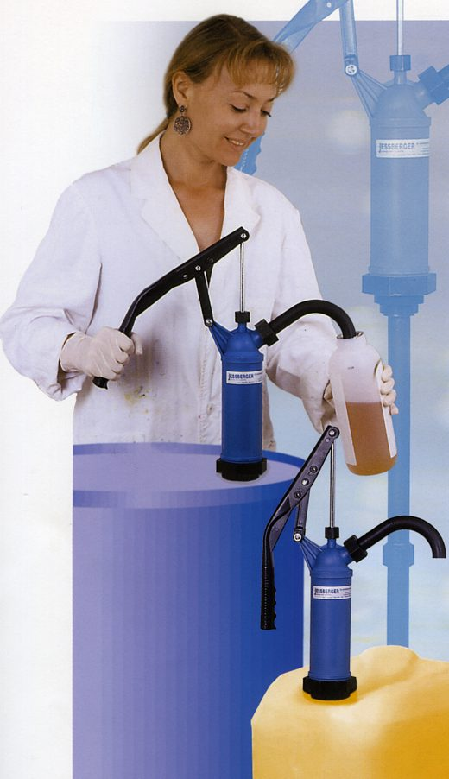



İDEAL MAKİNA ENDÜSTRİ ÜRÜNLERİ SAN. VE TİC. LTD. ŞTİ.
Tel. 0216 540 88 55 (pbx) Fax. 0216 540 88 18 www.idealmakina.com

